

Object-Oriented Program
Case study

Name: Harshit Sharma
UID: 24BCA10518
Subject: Object-Oriented Program (OOPS)
Section: 3A

Submitted To: Jyoti Rani
Designation: Assistant Professor

Topic: temperature conversion tool-convert celcius- fehrenheit

Abstract:
This project allows the user to convert temperature from Celsius to Fahrenheit and vice versa. It applies OOP concepts to organize the conversion logic within a class, making the program modular and reusable.
It also demonstrates encapsulation by keeping temperature data private and function overloading to handle both types of conversions.

Objective:
To design a simple program that converts temperature values between Celsius and Fahrenheit using the concepts of Object-Oriented Programming (OOPs) such as classes, objects, encapsulation, and function overloading.

Key OOP Concepts Used:
- Class and Object: The class Temperature is used to perform conversions.
- Encapsulation: Data is kept private, and access is controlled through public methods.

- Function Overloading: Two methods with the same name
convert() are used for converting in both directions.
- Abstraction: The internal formula for conversion is hidden from the user.

Formula Used:
- Celsius to Fahrenheit: F = (C × 9/5) + 32
- Fahrenheit to Celsius: C = (F − 32) × 5/9

Sample Code (C++):

#include <iostream> using namespace std;

class Temperature { private:
float value; public:
// Constructor Temperature(float v = 0.0) {
value = v;

}

// Convert Celsius to Fahrenheit float convertToFahrenheit() {
return (value * 9 / 5) + 32;
}

// Convert Fahrenheit to Celsius float convertToCelsius() {
return (value - 32) * 5 / 9;
}
};

int main() { int choice; float temp;

cout << "===== TEMPERATURE CONVERSION TOOL =====\n";
cout << "1. Convert Celsius to Fahrenheit\n"; cout << "2. Convert Fahrenheit to Celsius\n"; cout << "Enter your choice: ";
cin >> choice;

if (choice == 1) {
cout << "Enter temperature in Celsius: "; cin >> temp;
Temperature t(temp);
cout << "Temperature in Fahrenheit: " << t.convertToFahrenheit()
<< " °F\n";
}
else if (choice == 2) {
cout << "Enter temperature in Fahrenheit: "; cin >> temp;
Temperature t(temp);
cout << "Temperature in Celsius: " << t.convertToCelsius() << " °C\n";
}
else {
cout << "Invalid choice.\n";
}

return 0;
}

Output 1:

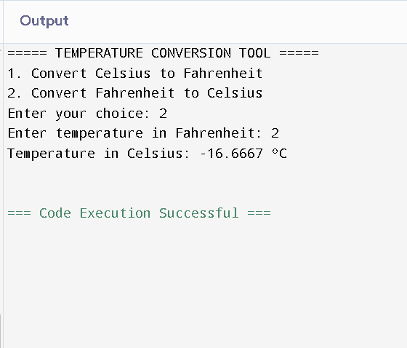
Output 2:
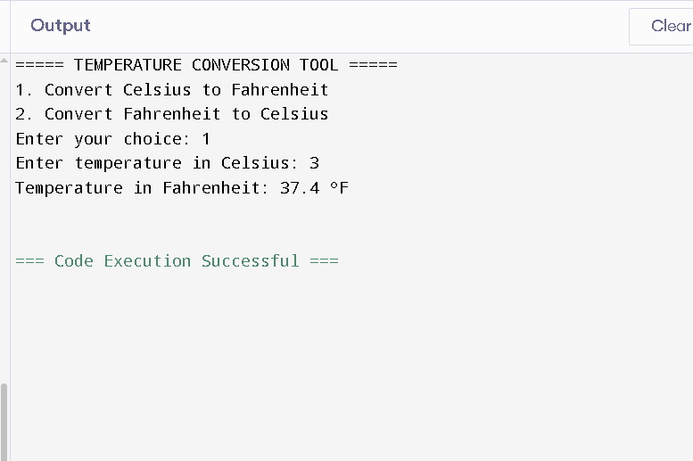

Conclusion:
This mini project demonstrates how OOP principles can be used to build a simple and efficient program.
It highlights encapsulation, abstraction, and class-based design, making the code organized and easy to expand — for example, by adding conversions to Kelvin or Rankine later.

**THANK YOU**

